In28minutes – Junit GIT url -

<https://github.com/in28minutes/MockitoTutorialForBeginners>

Stubs –

- Stub class - Hard coded class

- Every time you need to create/ change stub class written for System Under Test (method/ class to test).

- Difficult to maintain.

- Ideal for small apps.

E.g. ToDoService, ToDoBusinessImpl -> ToDoBusinessImplStub, ToDoBusinessImplTest

Mocks –

- Used almost everywhere now.

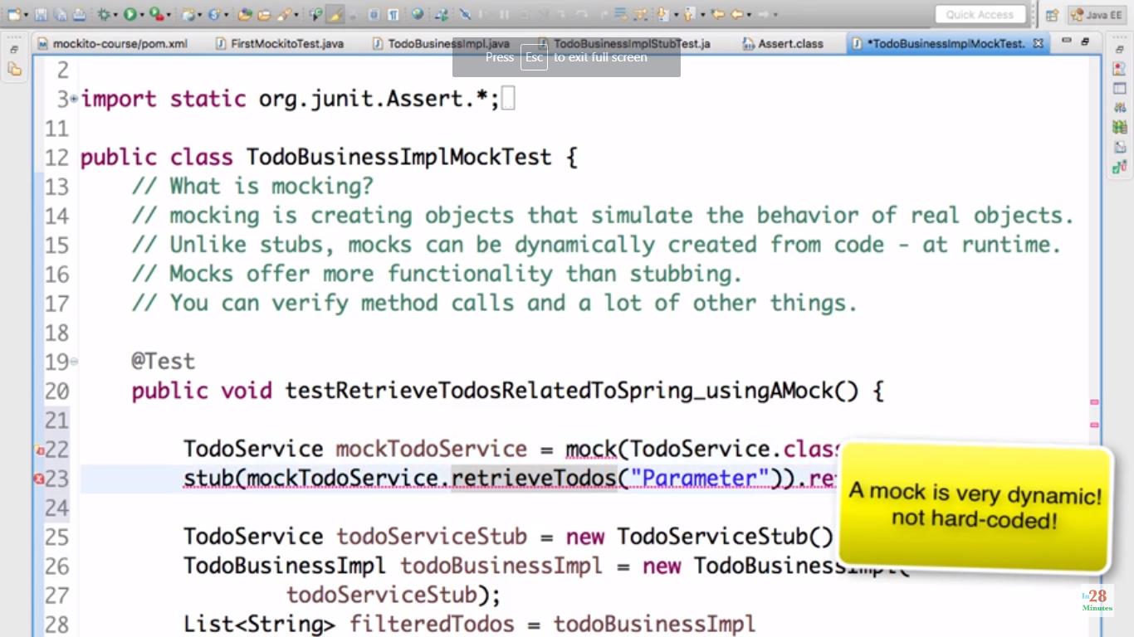

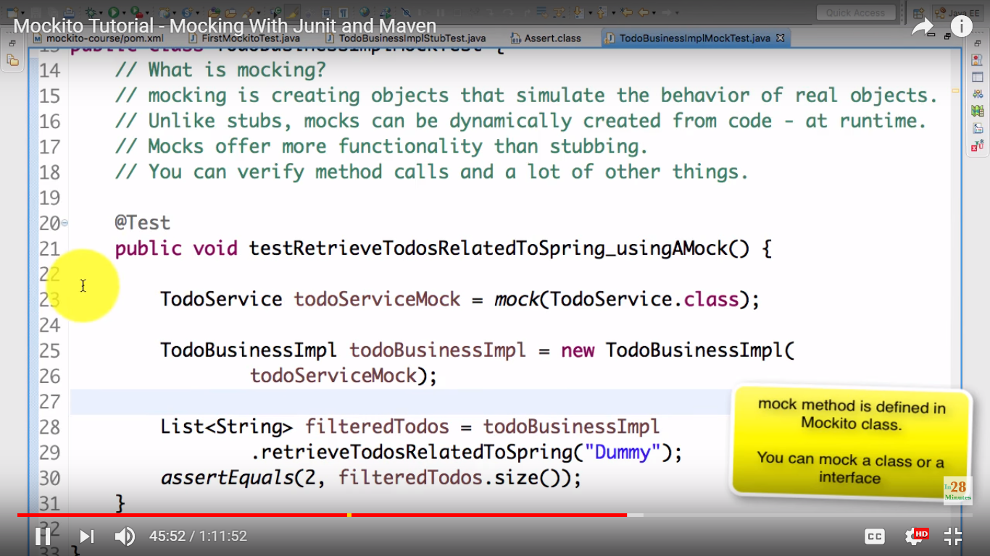

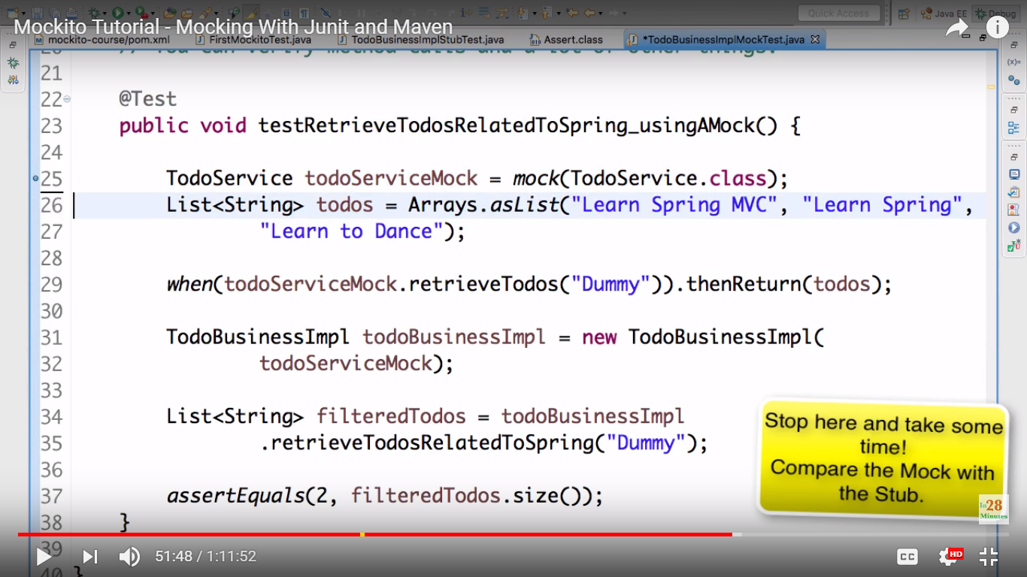

Annotations -

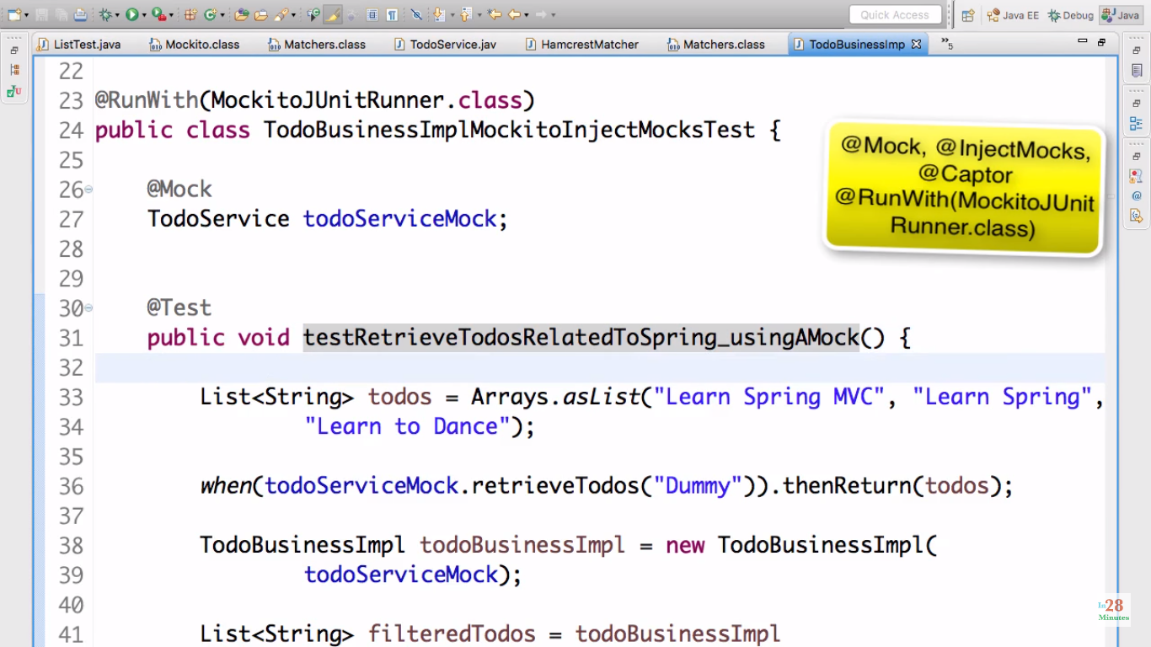

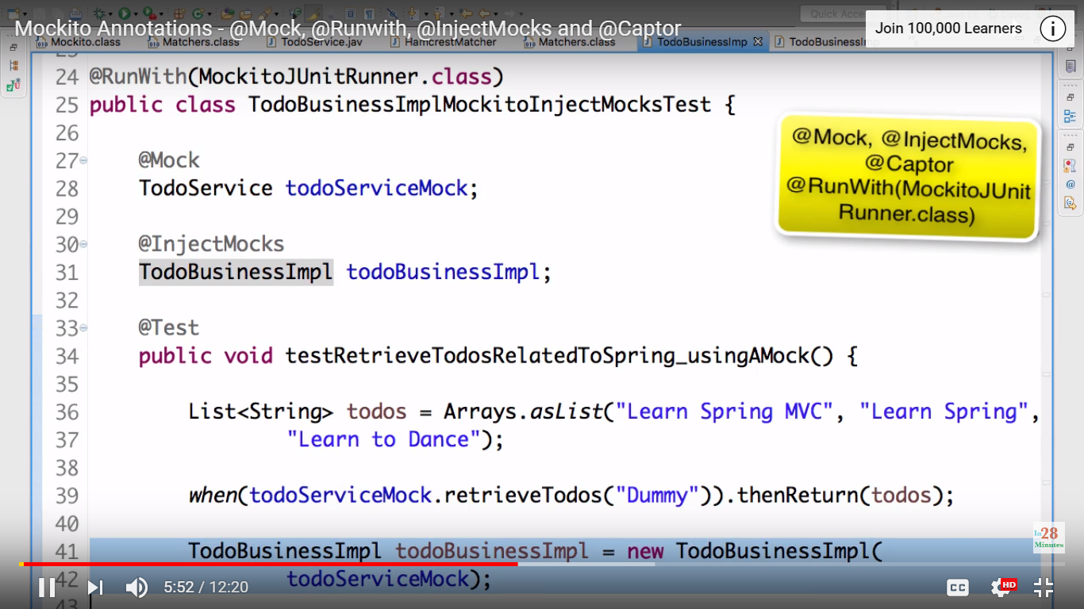

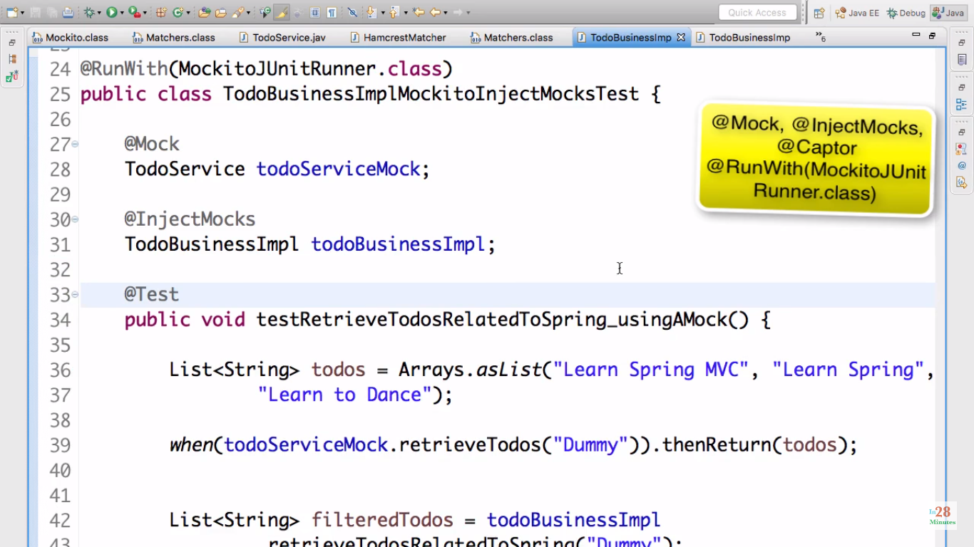

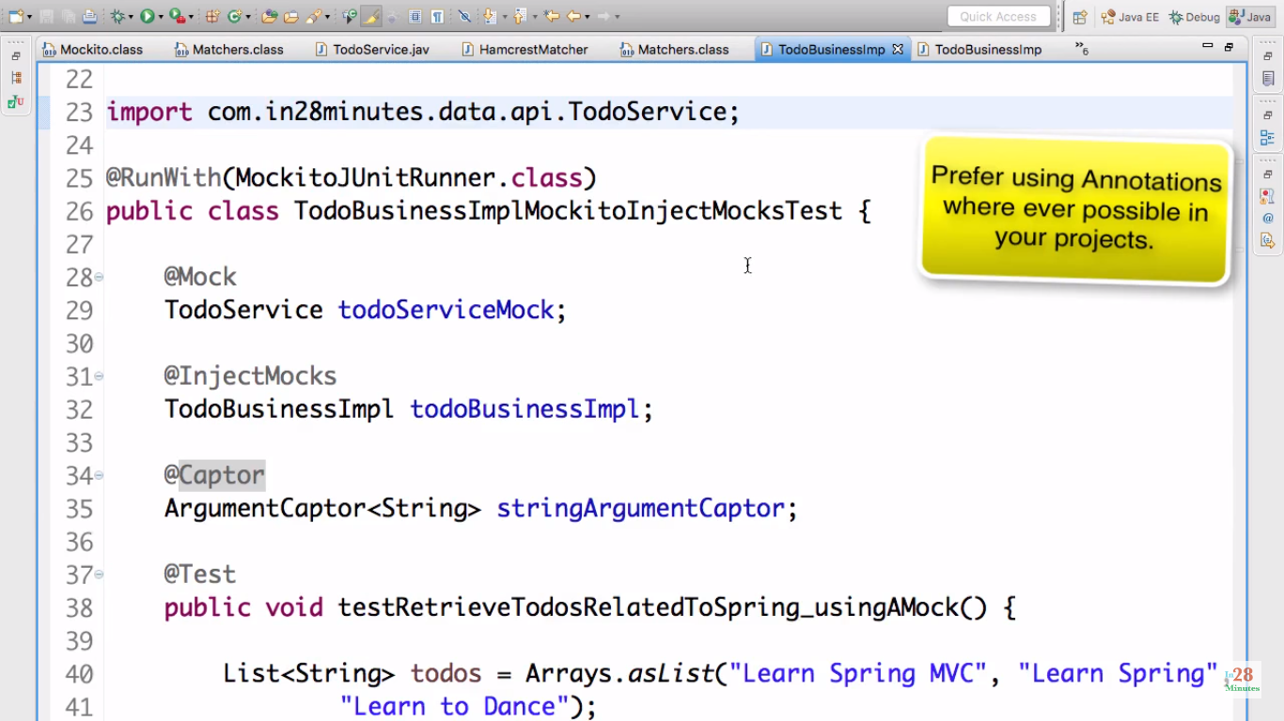

For testing private, static, final (maybe) method –

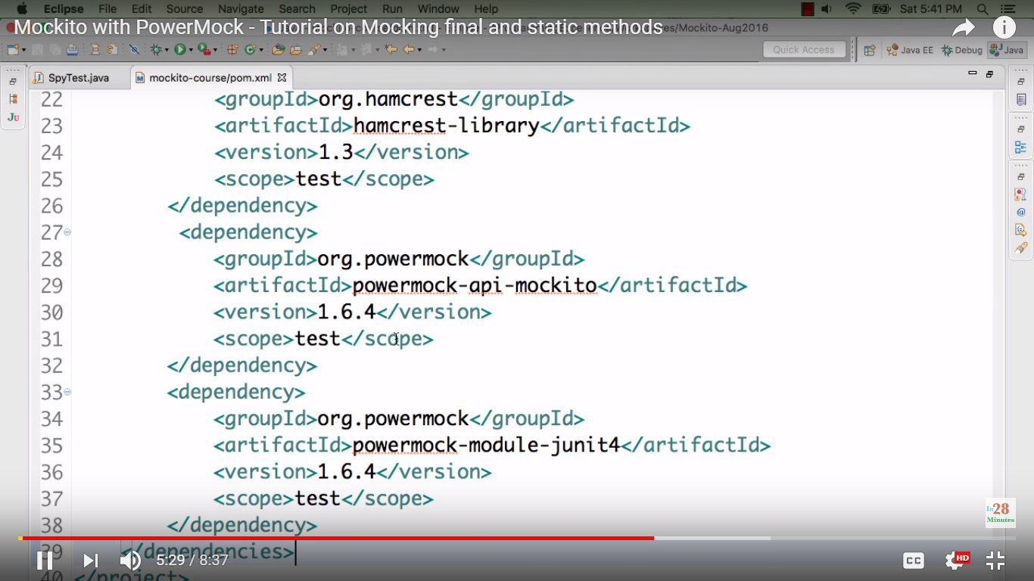

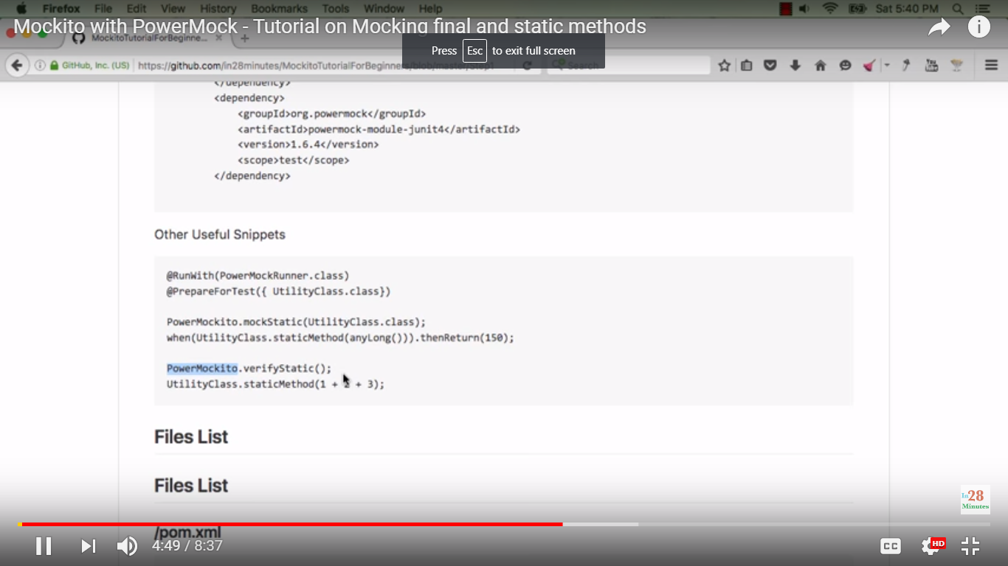

Spy –

- To retain implementations of all methods of a class except few – use spy.

i.e. overriding behavior of some of the methods

E.g. ArrayList’s add() method

Without spy() it will not consider add, remove operations on it.

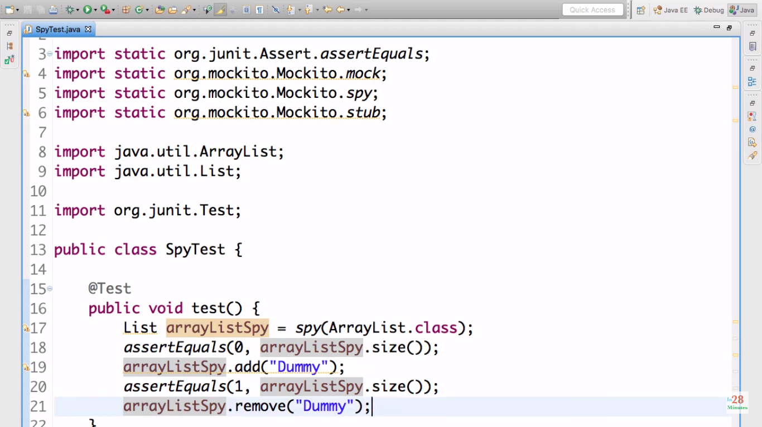

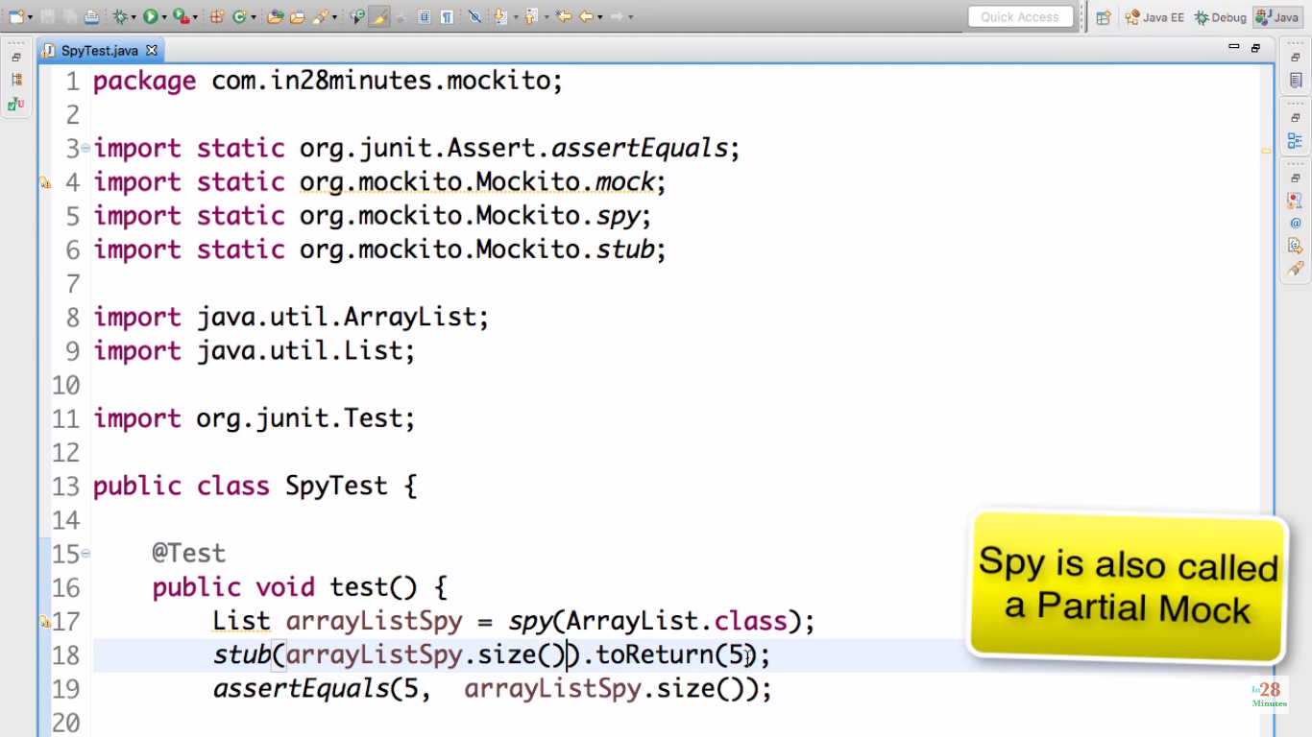

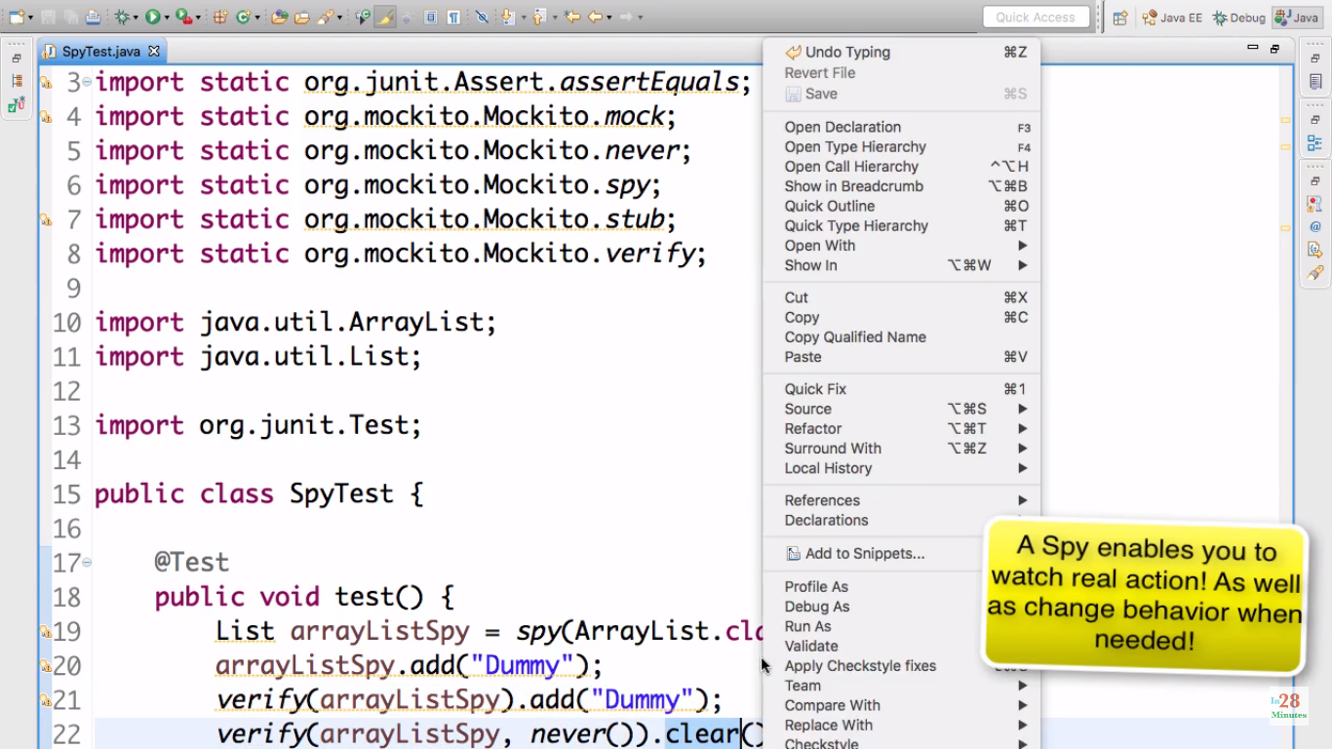

They’re called partial mocks.

Note – Avoid using spys in actual junits.